**Ideation Phase Define the Problem Statements**

|  |  |
| --- | --- |
| Team ID | PNT2022TMID14015 |
| Project Name | Project - Emerging Methods for Early Detection of Forest Fires |
| Maximum Marks | 2 Marks |

**Customer Problem Statement Template:**

Create a problem statement to understand your customer's point of view. The Customer Problem Statement template helps you focus on what matters to create experiences people will love.

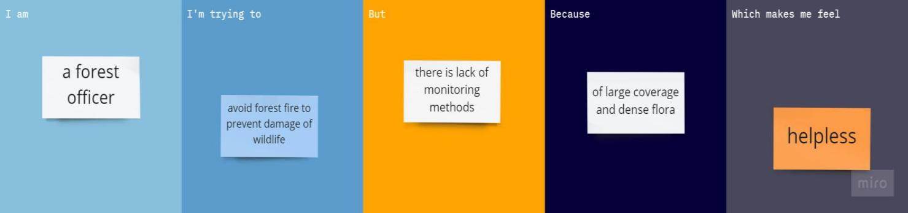A well-articulated customer problem statement allows you and your team to find the ideal solution for the challenges your customers face. Throughout the process, you’ll also be able to empathize with your customers, which helps you better understand how they perceive your product or service.

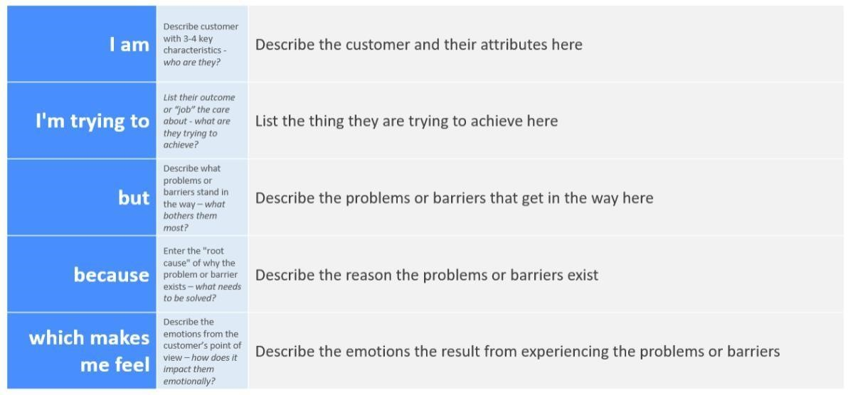

**Customer Problem Statement Template:**

|  |  |  |  |  |  |
| --- | --- | --- | --- | --- | --- |
| **Problem**  **Statement (PS)** | **I am**  **(Customer)** | **I’m trying to** | **But** | **Because** | **Which makes me feel** |
| PS-1 | A forest officer | Avoid forest fire to prevent damage of  wildlife | There is lack of monitoring methods | Of large coverage and dense  flora | Helpless |
| PS-2 | A firefighter | Stop the  forest fire | Fire can’t be  controlled | Of delay of information | Dejected |